

University Foundation Programme

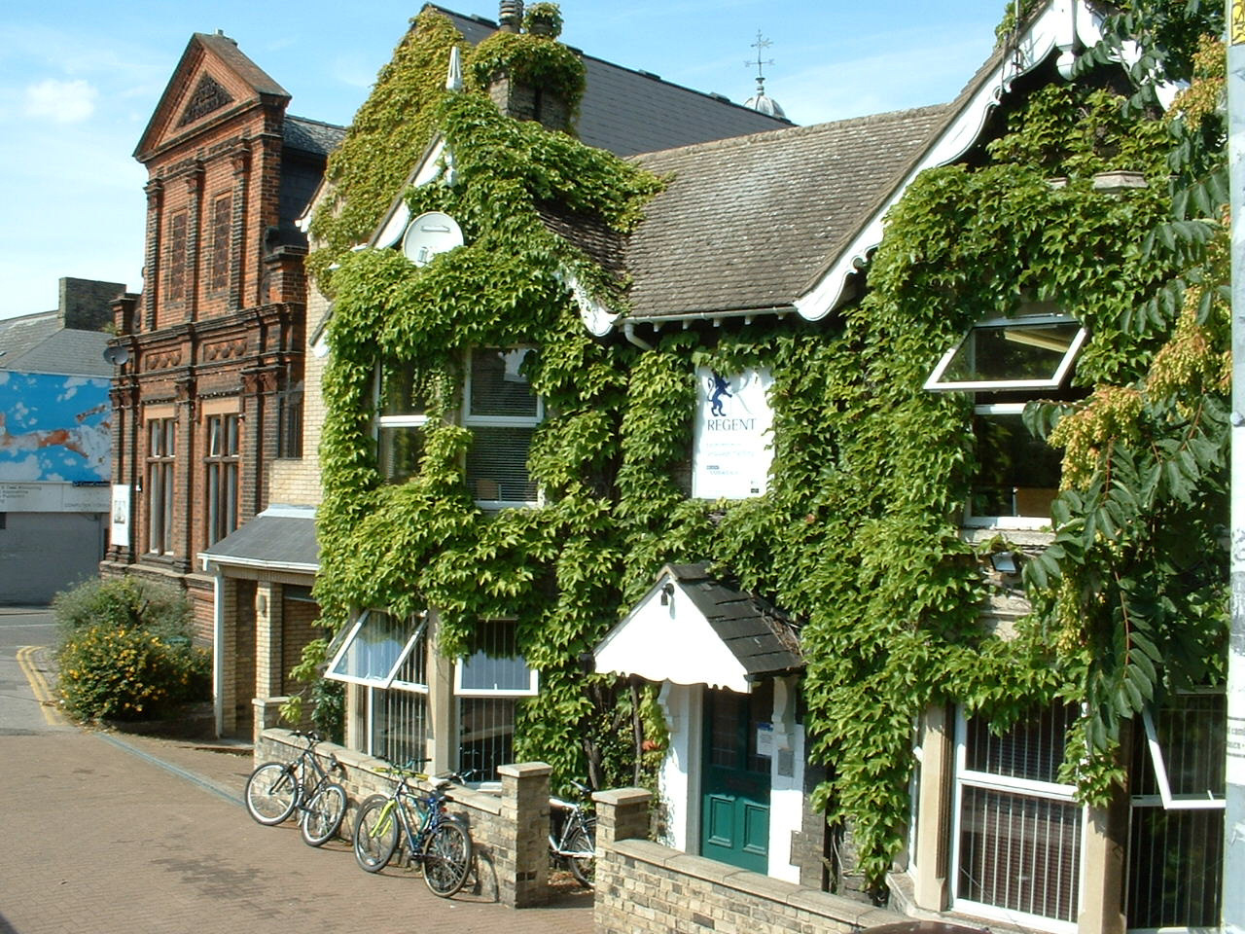

Regent Cambridge University Foundation Programme

The Regent Cambridge University Foundation course is designed to provide with the academic knowledge and skills necessary to study successfully at a UK university on a range of business and business related degree courses such as:

- Business Administration
- Marketing
- Finance and Accounting
- Economics
- Humanities
- Social Sciences
- Politics
- Tourism
- Hotel Management

If you are interested in studying any of these subjects at University then the University Foundation Programme is definitely for you! If you have a different subject which you are interested in then please speak to us as the course can still be relevant to you.

Equal importance is given to development of subject knowledge and understanding as it is to academic skills development. This means that along with studying these specific subjects you will also be able to improve the academic skills which you will need for university such as essay writing, note taking and taking part in seminars. These skills are invaluable when starting a course at university and will help you to make the most of your studies.

The programme also covers personal skills needed for university in the UK such as ‘Personal Finance’ and ‘Student in the Environment’. These subjects will help you to be more independent once you are at university and to integrate culturally into university life.

Course Objectives

On successful completion of the course you will have:

• Gained knowledge and understanding of a range of core concepts in Business Studies, Economics, Management and Communications, and
Finance and Accounting in preparation for starting a business orientated
degree course .
• Gained language skills required for university level study.
• Acquired the range of academic skills necessary for successful study at university level.
• Acquired a range of supporting practical and personal skills e.g. Information Technology Skills.
- Undertaken course work, projects, case studies and examinations.
- Maintained a portfolio of work for inspection.

The Regent Foundation course develops your skills in four key areas:

Language Skills
Competency in English language is essential for successful study at a
UK university. You will receive English language tuition focussed on preparing you for the IELTS exam. You must achieve a score of at least 6.0 to pass the English component of the Foundation Course.

Academic Skills
The academic side of the course is designed to provide you with an understanding of key concepts in a number of business-related subject areas. The development of academic skills is highly important in the course and these skills include: analysis and reasoning, problem formulation and problem-solving skills. You will also develop research skills by putting together portfolios and course work in a number of real life situations.

Skills Development
A key objective of the Foundation Course is to develop the skills needed for study at a UK university. You are encouraged to adopt an active and participatory approach to your studies, taking responsibility for your learning. Study skills sessions will deal with the practical issues of note taking, constructing arguments, paragraph and essay writing skills and the development of presentation skills.

Information Technology Skills
The course will prepare you for the types or skills you will need during university study. It also focuses on the use of Information Technology as a business tool and you will be assessed on the use of IT made in your academic coursework.

Entry Requirements

- High School Certificate or recognised equivalent from home country
- IELTS 4.5 (or equivalent)
- Age on Entry: 17 years
- Completion of the UFP entry test with a percentage of 60% or above.

In exceptional circumstances students without High School Certificates will be considered. Students that can offer evidence of significant academic achievement will be considered on merit by the College.

Students with adequate academic qualifications but an inadequate level of English Language will be offered places on an English bridging course as an alternative to direct entry onto the Foundation Programme. It is then possible to enter the Accelerated University Foundation Programme

Accelerated University Foundation Programme Entry Requirements:

- High School Certificate or recognised equivalent from home
country
- IELTS 5.5 (or equivalent)
- Age of Entry: 17 Years
- Completion of the UFP entry test with a percentage of 70% or above

Course Dates

Standard University Foundation Programme

Term One: 11 October – 19 December
Term Two: 27 December – 10 April
Term Three: 18 April – 19 June

Accelerated University Foundation Programme

Term One: 27 December – 10 April 2010
Term Two: 18 April – 19 June 2010

Successful Candidates

Successful candidates have access to the majority of British universities via UCAS (University admissions service) Recent graduates have been offered places at prestigious universities such as:

- Royal Holloway
- Oxford Brookes
- Cardiff University
- London School of Economics
- Loughborough University
- Exeter University
- Aston Business School

We have a dedicated university counsellor who will help you with all aspects of the entry procedure into university which includes choosing the right course at the right university and filling in all the necessary application forms.

Sample Timetable

Day/Time | 9.00-10.30 | 10.30 – 11.00 | 11.00 – 12.30 | 12.30 – 1.30 | 1.30 – 3.00 | 3.15 – 5.00
Monday | Study Skills | Break | Economics | Lunch Break | Personal Finance | Self Study
Tuesday | Man & Comms | Break | Finance & Acocunting | Lunch Break | English Core language | Self Study/  Research Assignment
Wednesday | Finance & Accounting | Break | Study Skills | Lunch Break | Student in the environment | Self Study/  Research Assignment
Thursday | Man & Comms | Break | Economics | Lunch  Break | Research  Assignment | Self Study
Friday | Economics | Break | Man & Comms | Lunch  Break | English Core language | Self Study

The Regent Promise

WE PROMISE THE FOLLOWING SERVICES ON OUR COURSES:

- Welcome and orientation on the first day
- Individual assessment of language and level needs
- Regular progress reports and feedback
- Regular tutorials with teachers
- Free access to the internet and email on courses for adults
- All necessary learning materials
- Activity and excursion programme
- 24-hour emergency support line
- Counselling for your future academic or work life

Why Choose Regent Cambridge?

Regent Java Café
Our café offers hot and cold drinks, sandwiches, snacks and hot food during breaks. The private patio garden is a great place to relax with new friends in the summer.

Year Round Residence Available
Year round residential accommodation is available through Regent Cambridge for those of you who do not wish to take advantage of our homestay option. Purbeck house offers apartments each with their own self catering kitchen, private bathroom and internet access. Purbeck is centrally located just 10 minutes walk to the city centre.

Weekend Opening
The school now opens most Sunday afternoons between 2pm and 6pm. You can meet up at school to socialise, study, watch TV or check your email and browse the internet.

Perfect Location
The school itself is located in a busy and interesting area in central Cambridge. We are 5 minutes walk from the train station and 15 minutes walk from the city centre. Cambridge is also a great location; only 45 minutes by train from central London and 30 minutes to London Stansted airport.

Regent Cambridge Facilities

Regent Cambridge Computer Centre:

available to all students for self study during the day



Regent Cambridge Student Lounge:
a great place to relax with free internet access for all students



Regent Cambridge Java Café:
meet with friends at lunch and break times



Social Programme

Learning English in the classroom is very important, but it’s also vital to practise in a more relaxed setting. Join our programme of social activities and you will have fun and learn lots of English at the same time. Look out for new activities and how to book on our social programme board.

Typical Week

Day Time Activity
Monday 15:00 Walk in Cambridge City Centre
Tuesday 19:00 Trip to the Cinema
Wednesday 15:45 London Musical
Thursday 22:00 Ballare - International Student Night
Friday 15.00 Table Tennis Competition in School
19.30 Pub night
Saturday 08.00 Day Trip to London
Sunday 08.00 Day Trip to Stratford and Warwick Castle

CAMBRIDGE NIGHT LIFE
There is plenty to do in Cambridge - from a night at one of the theatres, a trip to the cinema, or dancing the night away at a club. Classical music concerts and organ recitals take place in many college chapels, and there are a number of pubs with regular live music.

WEEKEND EXCURSIONS
Every weekend we offer full day guided excursions to places of interest all over England: Brighton, Oxford, London, Stratford-upon-Avon, Bath and many more. Details are on the activities board in reception. Ticket’s can be purchased from reception. Most tours cost £20-30.

Even more exciting: we offer regular international weekend trips to Amsterdam, Paris and Edinburgh!!

What Our Students Say About Us…

'Regent school is one of the best and most professional schools in the UK. It was very nice to study at this school and I would like to come back.'
Bekkhan, Russia

'I think Regent school is very good because people from all over the world have the chance to learn English with fine teachers and at the same time they have the opportunity to make friends with people from different countries and learn about their culture and way of life. The staff are very welcoming and helpful to the students and are always available for information'
Giulia, Italy

'I had a really great time at this school. I'd like to come back here and I’m sure that next time will be even better. Thanks a lot.'
Danko, Russia

‘Thank your student for the wonderful atmosphere of the school, for the high professionalism in teaching as well as for your kindness and helpfulness. I found the methods and materials of teaching to be of very high quality and variety and they have completely responded to my original need of improving my language skills. This course has been extremely inspiring, helpful and educative and it has been a great pleasure to study in such a friendly and relaxed atmosphere. Certainly to be recommended. Keep up the good work!
Johanna, Belgium

School Details

1. School name: REGENT CAMBRIDGE

2. Address: 119 Mill Road, Cambridge, CB1 2A

3. Phone number: +44 (0)1223 312333

4. Fax number: +44 (0)1223 323257

5. Email address: cambridge@regent.org.uk

6. Website: www.regent.org.uk

7. Staff: Principal: Nicholas Phillips
Academic Manager: Niamh Murphy
Enrolment Services: Nicola Albert
Accommodation: Vladka Ciesarikova
Client Services: Margaret Provis

8. Office hours: Monday - Friday, 8.45 a.m. - 5.30 p.m.

If you have any questions whatsoever regarding any of our services please do not hesitate to contact a member of our friendly and helpful team who will be more than happy to help.



